TASK 23:
import java.util.*;

class Solution {
public boolean isValid(String s) {
Stack<Character> stack = new Stack<>();
Map<Character, Character> map = new HashMap<>();
map.put(')', '(');
map.put('}', '{');
map.put(']', '[');

for (char c : s.toCharArray()) {
if (map.containsValue(c)) {
stack.push(c);
} else if (map.containsKey(c)) {
if (stack.isEmpty() || stack.pop() != map.get(c)) {
return false;
}
}
}
return stack.isEmpty();
}
}

CASE 1:
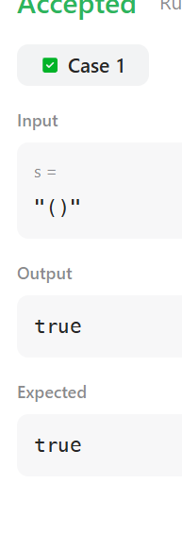
CASE 2:

